

**QUARTERLY NEWSLETTER PROMOTING ARTS & CRAFTS IN SELWYN DISTRICT**

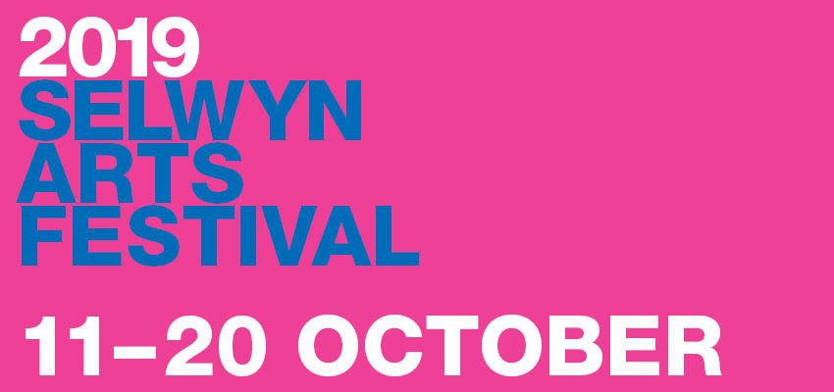

# **Spring 2019**

Celebrate with us at the inaugural Selwyn Arts Festival!

The rich and diverse event programme traverses the district with demonstrations, workshops, live art competitions and behind the scenes glimpses of theatre-in-production. And plenty of chances for you to buy new, original pieces and the opportunity to meet the makers

Anchored by the established *Darfield Artweek* and *Art Couture*, plus new events and opportunities for you to see, try and taste the arts have emerged with both *Art Crawl* and *Try the Arts on, see how they fit*.

*Brought to you by the Selwyn District Council, in collaboration with Lakeland Gallery, Down by the Liffey Gallery, Selwyn Gallery, Darfield Artweek, Art Couture and supported by Taste of Life Tours.*

# **Arts Heart Selwyn at the Selwyn Arts Festival**

As part of the Arts Festival, Arts Heart Selwyn have organised a range of exciting workshops to give people the chance to take part in arts in a fun way during the period of the festival. These are featured on the following pages, we encourage you to pick something and give it a go!

For more information about the festival or to find out how to register for these events visit:

**https://www.selwyn.govt.nz/community/arts-festival-2019**

This Issue

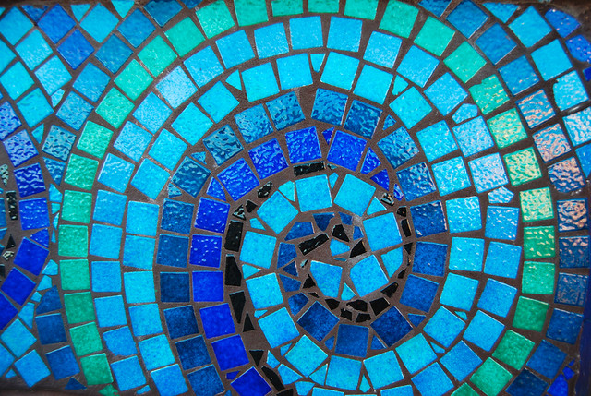

**P.2-5 Festival Workshops**



**P.6 Get Arty in Selwyn**

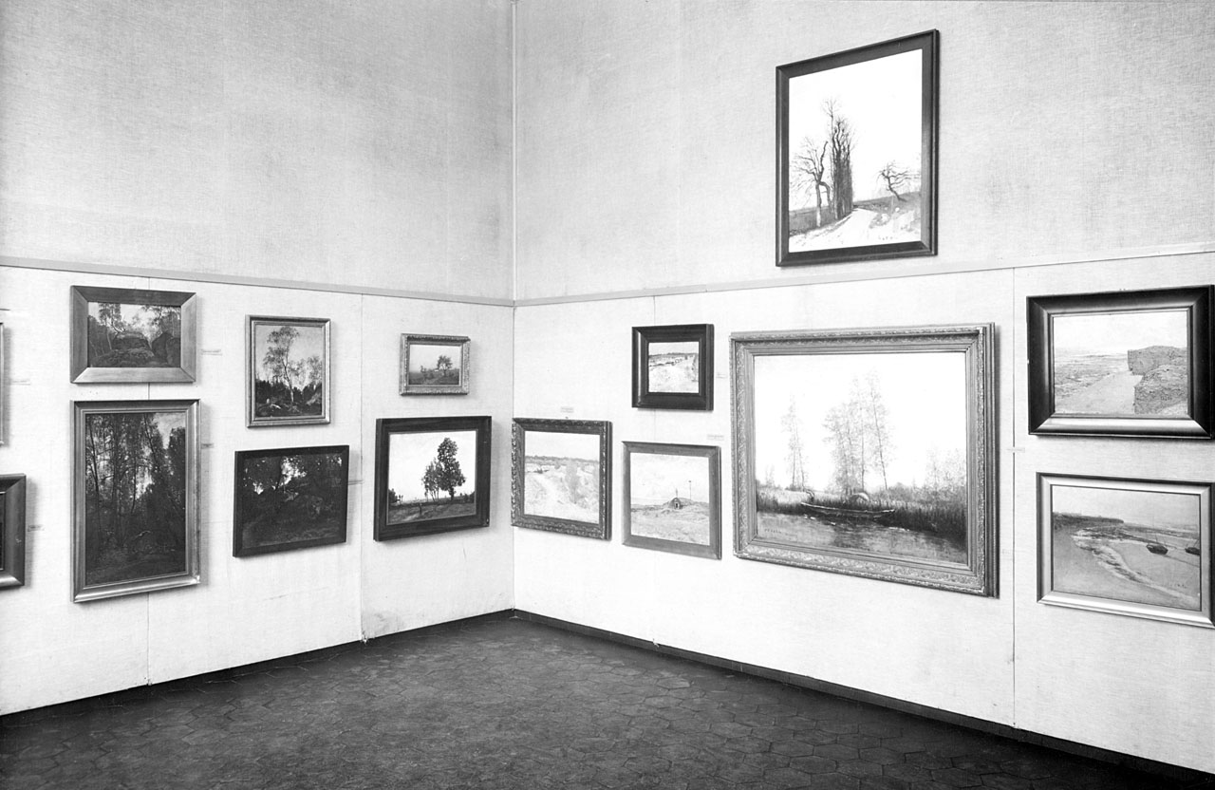

**P.7 Selwyn Galleries**



**P.8 Curtain Call**

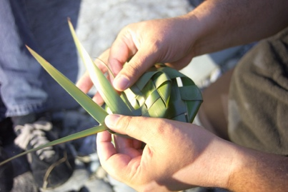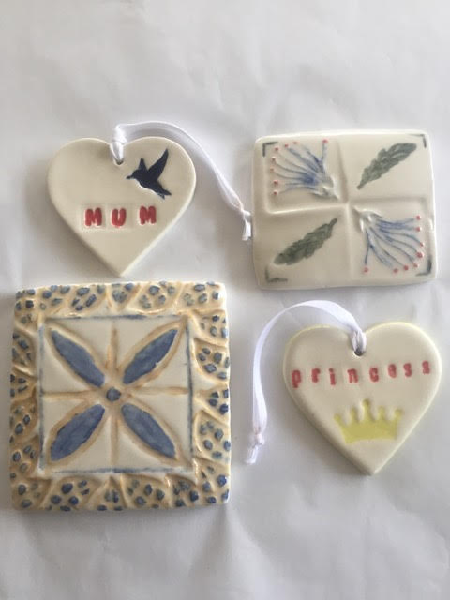

**Pottery Workshop Sunday 13 October**

**Any time between 10-3pm**

Our local ceramic tutor, Frank Hakkaart from West Melton Pottery will help you make a decorative tile. It will be held at the West Melton Community Centre. All ages welcome. Cost of $5 to get your work fired and clear glazed, you will need to pick up after 2 weeks at 7 West View Crescent, West Melton, tuesday - Friday 10-4pm or Saturday 10-2pm. Free to participate, no booking required.

Flax Weaving

Festival Workshops

Pottery

**Flax Weaving Workshop 13 October 10-1pm**

*West Melton Community Centre*, *Cost $20.00, Max 15 persons*

3 Tutors from the Kahu Collective will run a Putiputi (flower) Workshop

Corabelle Summerton a New Zealand artist with a specialty in weaving with Harakeke. After discovering weaving 5 years ago it has inspired her to find connection with her whakapapa and connect with her culture. Corabelle has a love of traditional Maori weaving adding a modern touch to create something incredible.

Cathy Payne is a Christchurch artist who holds a bachelor degree in Maori art from Te Wananga O Aotearoa, specialising in raranga. She considers herself privileged to have had the opportunity to be taught by and weave alongside  some of New Zealands master weavers. Cathy loves learning new skills and sharing what she has learnt with others.

Lisa Harding is a Maori artist based in North Canterbury, New Zealand. With whakapapa (genealogy) connections to Ngāi Tahu, Ngāti Maniapoto and Ngāti Hako. Lisa utilises Raranga (weaving) and Whatu techniques to create artworks immersed in tradition with a contemporary style. These pieces allow her to reconnect with her cultural identity and tell the stories of aspirations through natural fibres such as Harakeke (NZ flax). She loves to share her knowledge and has a passion for sharing her love of this beautiful art with the world.

[**https://www.eventfinda.co.nz/2019/flax-weaving-workshop/west-melton**](https://www.eventfinda.co.nz/2019/flax-weaving-workshop/west-melton)

**Selwyn Arts Festival**

**Art Class**

Photography



Art in a Box is a ‘Live Art’ competition where contestants each receive an identical box of mystery art ‘ingredients’ to create a piece of art that evokes a provided theme. This will take place in front of an audience within a set time period.

**Why?:** Fun, mainly, but also to encourage and give licence to creative, critical and spontaneous thinking by challenging participants to communicate a message without words or pictures. But also for the chance to exhibit your work in a local library and a possibly win a prize.

**Who?:** Experienced artists or other adults (18 and over)who want to discover their inner artist or rediscover their inner child.

**When:** Sunday 13 October from 1pm – 3pm

**Where:** West Melton Community Centre

**Cost:** $15

[**https://www.eventbrite.co.nz/e/art-in-a-box-live-art-display-tickets-70232203411**](https://www.eventbrite.co.nz/e/art-in-a-box-live-art-display-tickets-70232203411)

<https://www.eventbrite.co.nz/e/art-in-a-box-live-art-display-tickets-70232203411>

**Photography Workshop 20th October 10-3pm**

Tess Rait, Katrina Easton and Louise Bush, all experienced photographers, will lead participants for this fun day of learning. Participants only need to bring their camera and desire to learn something to get a better looking photo. Suitable for beginners to those who are proficient. A note book, a small torch and a cushion or tripod if you have an SLR camera, are good ideas.  Each participant will receive tuition on the basics of photography, focusing on the fundamentals which help you capture everyday images - aperture, shutter speed, ISO speed and exposure. Some ability to control these aspects on our camera would mean getting the best out of the day but is not essential. Participants can also think about ideas of a type of photograph they may want some specific help with.  All participants will get their three best photos printed and displayed allowing critique and learning from each others work.

Meeting at the West Melton Community Centre Room B which is entered from outside, round the back of the kindergarten. Cost $20,  20 maximum.

[**https://www.eventfinda.co.nz/2019/photography-workshop/west-melton**](https://www.eventfinda.co.nz/2019/photography-workshop/west-melton)

**‘Art in a Box’**

**Selwyn Arts Festival**

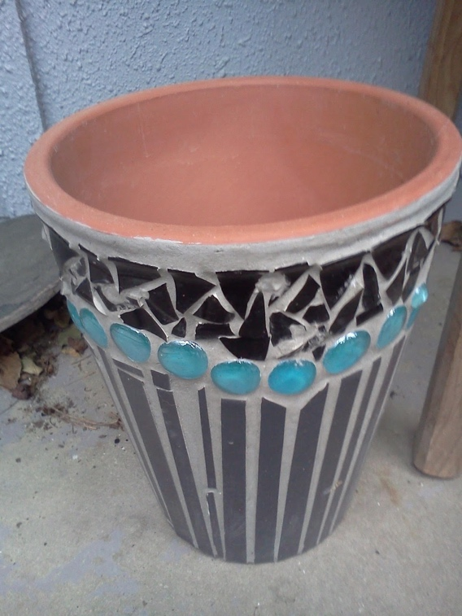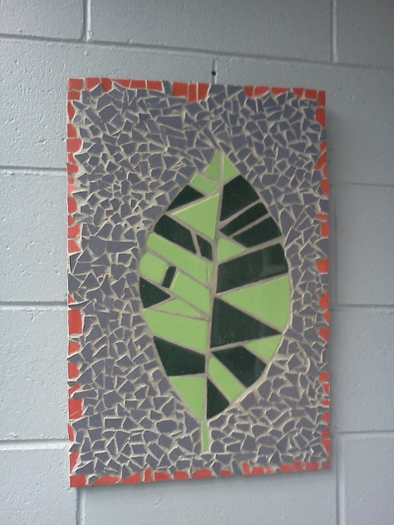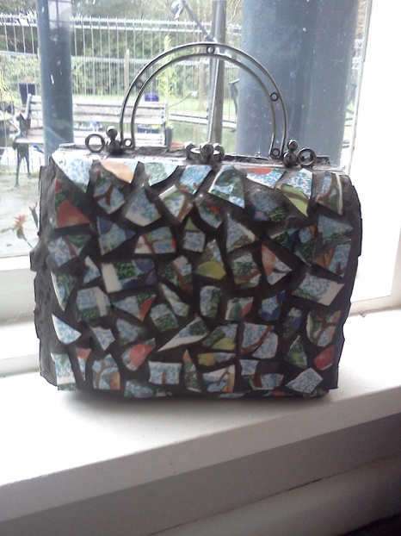

Mosaics

**Mosaics workshop**

**Sunday 13 October 10-3pm**

Rails Mackey and her team will help participants  almost completely finish a mosaic project of their choice.  All materials provided, wear your old clothes.  Mosaics are easy to make and it will be a fun day.  The project is to make a work of art on a tile to create a decorative object or useful coaster.  If desired participants can mosaic their own object.  A paver or vase can often work very well.  Once enrolled, participants can get some advice and be ready on the day.  Pieces will only be grouted once dry so the tutors will demonstrate this and send everyone home with the grout they will need.  An easy project for anyone.

West Melton Community Centre

Cost $20, 25 maximum

Participants are asked to allow their work to be displayed in a local library or at the community centre once completed.

[**https://www.eventfinda.co.nz/2019/mosaics-workshop/west-melton**](https://www.eventfinda.co.nz/2019/mosaics-workshop/west-melton)

**Selwyn Arts Festival**

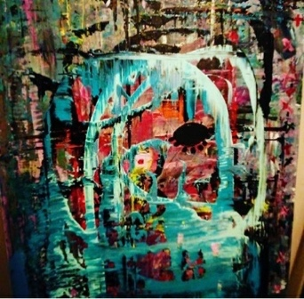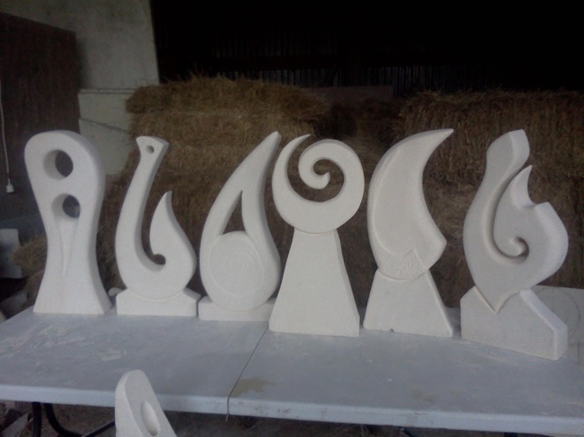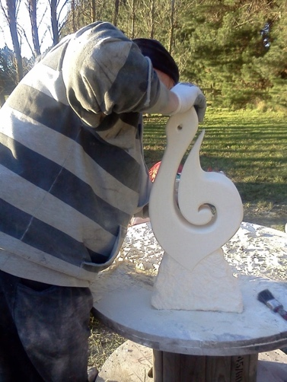

Local limestone carving legend Ross Mackey and helpers will lead 12 lucky participants at a limestone carving day.  Ross will prepare a work piece by sawing it out of a solid block.  Participatants will need to discuss their intended project prior to the day so that your own design can be created on the day.  All tools and safety gear provided, but old clothes are a good idea.  NO special skills needed. Take home an Oamaru sculpture for indoors or a sheltered spot outdoors

Cost $60 12  Maximum

Participants are asked to allow their work to be displayed in a local library or at the community centre once completed

[**https://www.eventfinda.co.nz/2019/limestone-carving/west-melton**](https://www.eventfinda.co.nz/2019/limestone-carving/west-melton)

**Limestone Carving**

**Sunday 13 October 10-3pm**

**Where:** West Melton Community Centre

**When**: 10am – 3pm Sunday 13 October

**Who**: Adults 18 & Over

**Cost:** $25

Come along and join us for a day of not drawing. This is a workshop for both experienced artists and adults who want to reacquaint themselves with their creatively uninhibited inner child through making abstract expressionistic and mixed media style art. Use provided materials to create an art piece inspired by a theme that will be announced on the day. At the start of the workshop and throughout the day there will inspiration in the form of talks, film and reference material.

There won’t be instruction, but there will be an exhibition and prizes. Due to the focus on creating with spontaneity and energy, work must be completed on the day and submitted for judging. Finalists will be exhibited in a Selwyn library and be in with a chance to win prizes.

[**https://www.eventbrite.co.nz/e/so-what-if-you-cant-draw-art-making-workshop-tickets-70230317771**](https://www.eventbrite.co.nz/e/so-what-if-you-cant-draw-art-making-workshop-tickets-70230317771)

**So what if you can’t draw?**

Limestone Carving

**Selwyn Arts Festival**

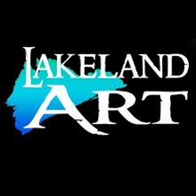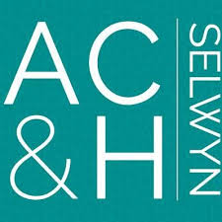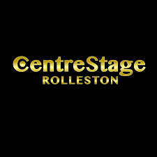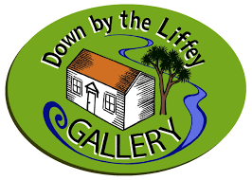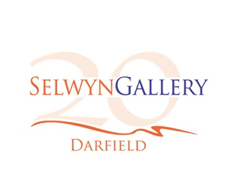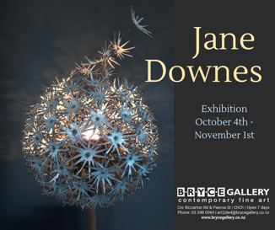

**Lakeland Gallery**

80 High Street, Leeston

* A painting group meets every Wednesday 10am -2pm
* Life Drawing classes (non-tutored) run on Wednesdays 7.30pm-9.30pm

Enquiries to Lakeland Art 027 8203 3045 Tue-Sun 10am – 4pm

**Malvern Community Arts Council**

Receive newsletters, invitations to previews and events. Membership forms can be found on the Selwyn Gallery website:

[www.selwyngallery.co.nz/become-a-friend](http://www.selwyngallery.co.nz/become-a-friend)

**Selwyn Creative Network**

[www.Selwyncreativenetwork.com](http://www.Selwyncreativenetwork.com)

**Down By the Liffey Gallery**

1 James Street, Lincoln

Open Weds – Sun, 10am – 4pm

[www.downbytheliffeygallery.com](http://www.downbytheliffeygallery.com/)

**Arts, Culture and Heritage Selwyn**

[Facebook.com/ACHSelwyn](http://facebook.com/ACHSelwyn)

**Nut Point Centre**

**222 Langdales Road, West Melton**

[www.nutpoint.org](http://www.nutpoint.org)

**CentreStage Rolleston**

Rolleston’s own community theatre group. See their website or Facebook page for upcoming events.

[www.centrestagerolleston.org.nz](http://www.centrestagerolleston.org.nz/)

**West Melton Art Group**

“Painting for Pleasure” at West Melton Community Centre

Tuesdays 10am – 1pm (untutored), $10/month

Contact Chris Wells [christinemarywells@gmail.com](mailto:E.Mail.....christinemarywells@gmail.com).

**Creative Sparks**

Art and music education for all ages from pre-schoolers to adults at their studios in Darfield

[www.creativesparks.net](http://www.creativesparks.net)

**Email artsheartselwyn@gmail.com if you would like to be featured on this page**

**Get Arty in Selwyn!**

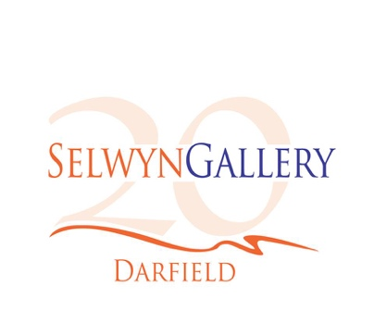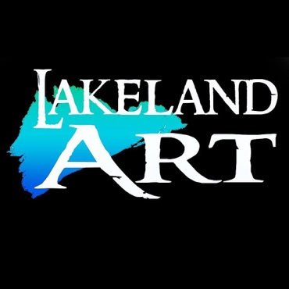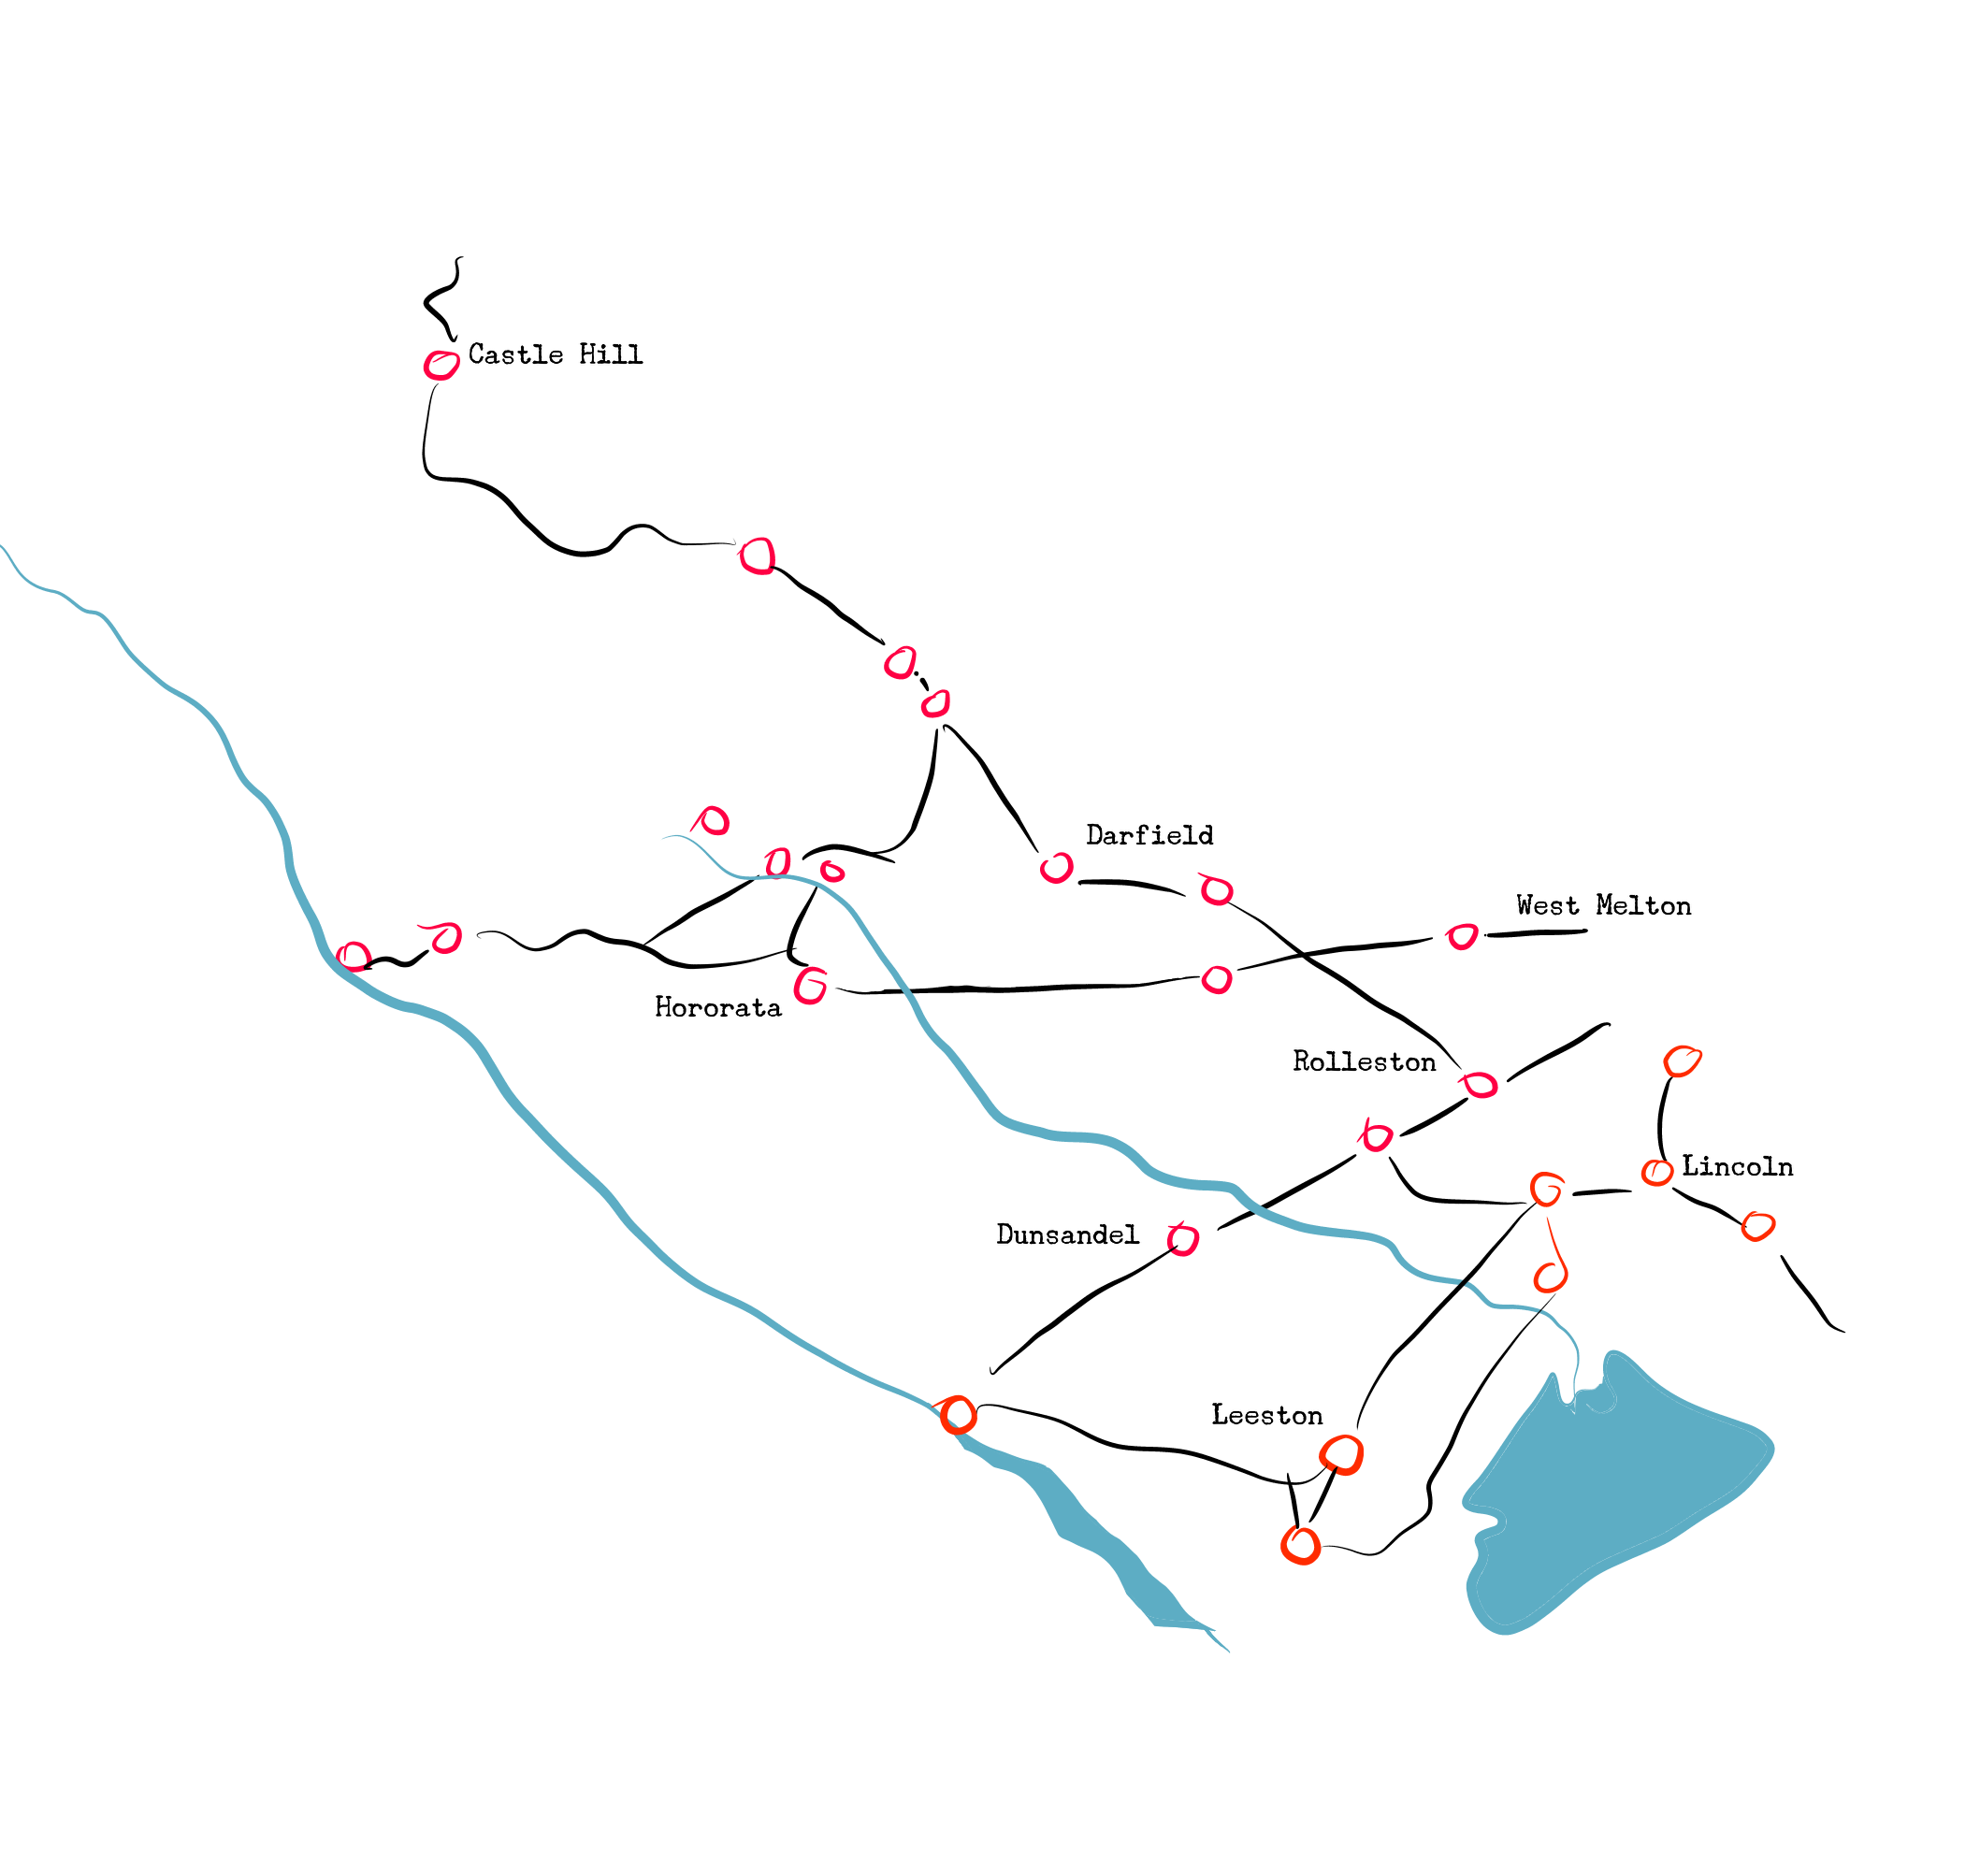

**Selwyn Gallery**

17 South Terrace, Darfield

Tuesday – Sunday, 10am – 4pm

[www.selwyngallery.co.nz](http://www.selwyngallery.co.nz)

**Galleries in Selwyn**

**Down By the Liffey Gallery**

1 James Street, Lincoln

Wednesday – Sunday, 10am – 4pm

[www.downbytheliffeygallery.com](http://www.downbytheliffeygallery.com/)

**Lakeland Gallery**

80 High Street, Leeston

Tuesday – Sunday, 10am – 5pm

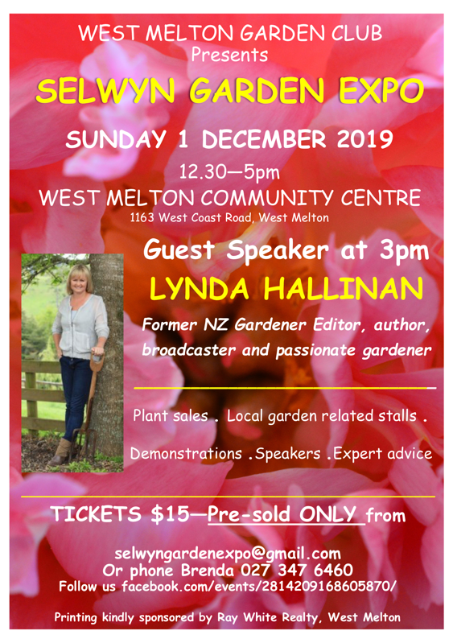

Looking Ahead…

**Curtain Call**

**Arts Heart AGM**

The 2019 Annual General Meeting of Arts Heart will be held on Monday 11th November 6.30pm – 7.30pm in the Rolleston Library. All are welcome to attend.

**Selwyn Garden Expo**

**Annual Arts Heart Exhibition**

The Annual Arts Heart Selwyn Art Exhibition will be held from the 3rd to the 5th of April 2020. Artists who live, work or play in the Selwyn region are invited to contribute artworks to this exhibition that celebrates the wide variety of talent that can be found in the Selwyn District. Keep an eye on our Facebook Page at the start of the New Year for more information.

**Facebook Page:**

/ArtsHeartSelwyn

**Facebook Group:**

groups/Artsheartselwyncentral



Arts Heart Committee

**Chairperson / Treasurer:**  
 Wendy Rockhouse  
027-434-7681

**Secretary:**  
Suzanne Pickford

**Committee Members:**  
Judith Wenborn  
Jill Pickford  
Prue Thornton  
Janis Wasserman

Margaret White

Tessa Rait

David Ellena

The Arts Heart Committee meets every 2nd Monday of the month at 6.30pm in the Rolleston Library.

**Contact us…**

[secretaryartsheart@gmail.com](mailto:secretaryartsheart@gmail.com)  
artsheartselwyn@gmail.com

**Join us…**

Join as a member of Arts Heart Selwyn and get this newsletter direct to your inbox. Our members are artists, art enthusiasts and those who like to keep up to date with the arts in Selwyn. New members are welcome any time. Email for more information.

If you wish your art or organisation to be featured in a future issue of this newsletter send us an email!